Begriffe

Paradigms of Interaction 2

History 2

Video display units (1950s) 2

Personal Computing (1970s-1980s) 2

Hypertext (1940s-1960s) 2

World Wide Web (1990s) 3

Agend based interfaces 3

Multi-Modality 3

Ubiquitous Computing 3

Sensor-based and Context-aware Interaction 3

Augmented Reality 3

Virtual Reality 3

Humans and interactive Systems 4

Interactive system 4

Domain 4

Interaction Framework 4

Interface 4

Input-Output-channels 4

Human Memory Information types 4

Human Memory types of memory 5

Sensory Memory 5

Short-term memory 5

Long-term memory 5

Total time hypothesis 5

Modeling Interaction and Cognition 5

# Paradigms of Interaction

### Interaction Paradigms

Successful approaches to interactive systems that have helped make it easier to use technology.

### Batch Session

Individual programmers submitted jobs on punched cards or paper tape to an operator who then ran the individual jobs on a computer.

### Time sharing

single computer could support multiple users at once and programming became an interactive activity. Time sharing shifted programming as a preplanned set of instructions for a computer to an exchange between programmer and computer.

## page24image46676864Video display units (1950s)

### Sketchpad

allowed data to be represented visually, abstracted, manipulated and changed. It adapted the computer to the human’s way of thinking.

### Bootstrapping

Small programming components can be combined to create larger ones.

## Personal Computing (1970s-1980s)

### LOGO

programming language for children which demonstrated that powerful tools for hackers could be used by novices. It made use of a graphical “turtle” that could be commanded to draw shapes through simple English-based phrases (e.g. “turn left”).

### Smalltalk

simple, but powerful, visually based programming environment especially for personal computing.

### Windows and WIMP

Previous interfaces were command-line based. There was increased support for engaging in multiple tasks at once, with humans in control. Supporting multiple threads of interaction in conventional command line interfaces became complicated and difficult to manage. **Window-based** systems supported physical and logical separations of tasks.

### Xerox Star

introduced the first commercial WIMP interface.

### WIMP

Interface based on Windows, Icons, Menus and Pointers.

### page12image34073648Direct manipulation

creates the illusion of operating directly on data and objects, rather than giving commands to a computer. The first commercial success of a direct manipulation interface was the Apple Macintosh computer (1984).

## Hypertext (1940s-1960s)

Vannevar Bush proposed a “memex” apparatus, a desk with the ability to produce and store massive amounts of photographic copies of documents.

## World Wide Web (1990s)

The **WWW** was a revolutionary paradigm which lowered the barrier for access to the internet, lowered the barriers to creating and publishing information and increased the purchases of computers and their use. It led to the rapid growth and increased value of internet content including leisure and commerce.

The beginning of computer networks can be traced back to the 1960s where computers started to communicate with each other. This enabled **CSCW** (Computer-Supported Cooperative Work).

### Agend based interfaces

Agent-Based Interfaces started a departure from direct manipulation. It created the illusion of someone working on your behalf to perform the tasks.

### Multi-Modality

Multimodality allows people to engage in multiple tasks at once and to give input in different ways.

### Ubiquitous Computing

Researchers at Xerox PARC (1980s) attempted to move computing “off the desktop” and into everyday life, making computing seamless with everyday activities. Ubiquitous Computing also refers to a shift in computer to human ratios.

### Sensor-based and Context-aware Interaction

Context-aware computing extends the notion of ubiquitous computing. More invisibility and seamlessness of computing with everyday life.

### Augmented Reality

Combines physical world and digital content, Requires knowledge of environment. QR codes, IR sensors

### Virtual Reality

Replaces physical world with digital world, Gesture recognition, eye gaze, full body sensing

# Humans and interactive Systems

## Interactive system

The purpose of an interactive system is traditionally to aid a user in accomplishing a goal within an application domain.

### Domain

area of expertise and knowledge in a real world activity, consists of concepts

## Interaction Framework

An interaction Framework has four major components:

* The systems
* The user
* The input
* The output

One of the main issues in the interaction framework is that the system and the user have different languages.

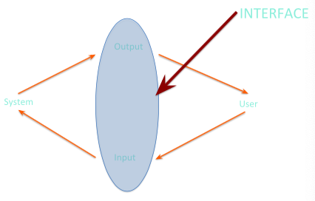

### Interface

An interface has the following requirements:

* The user needs to be able to articulate their goals and tasks in the input language specified by the interface
* The input needs to be translated into stimuli for the systems upon which the system can perform
* The new state of the system must be presented as output as specified by the interface
* The output must be observed and interpreted by the user

## Input-Output-channels

### Human Memory Information types

Factual, procedural & experiential knowledge

### Human Memory types of memory

Sensory, short-term/working & long-term memory

### Sensory Memory

Serves as buffer for incoming sensory input

* Iconic memory – for visual stimuli
* Echoic memory – for aural stimuli
* Haptic memory – for touch stimuli

Most information is filtered out and lost. Rest gets transferred to short-term memory

### Short-term memory

Working memory is a temporary storage for information that is currently being used. Can be accessed rapidly but also decays rapidly. Has limited capacity (7 ± 2 units).

Information can be “chunked” – combined into larger units, thus increasing short-term memory capacity. Is subject to recency effects, may have different channels for different types of information.

Information is transferred to long-term memory through repetition or rehearsal.

### Long-term memory

Main repository for memory; stores factual, experiential, and procedural knowledge; has potentially unlimited capacity, but slow access time. Meaningful information can be learned more easily

Two types of long-term memory:

* Episodic – memory of events and experiences in a serial form
* Semantic – structured record of facts, concepts, and skills, structured as a network

#### Total time hypothesis

the more time spent learning, the more will be learned. Distribution of practice effect – learning is more effective if it is distributed over time

# Modeling Interaction and Cognition

## Interaction Models

### Model Definition

A constructed representation intended to help understand and reason about the world, or some phenomenon in the world.

### Interaction Models

Tools for modeling and thinking about how humans interact with objects or systems. Different models enable different types of thought, tasks, explanations

### Purpose of Interaction Models

* Predict human performance
* Understand the interactions and interaction cycles
* Explain physical and cognitive processes
* Examine individual parts of the interaction

## Fitts’s Law

Essentially a formulation of the idea that movement time is proportional to distance and target size

### Movement time

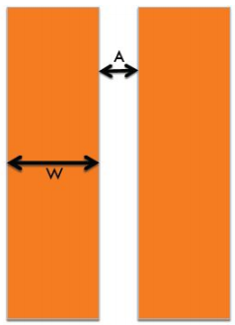Movement Time (MT) is proportional to the Index of Difficulty (ID) of a selection task. Increases as the distance A to the target increases; and decreases as the size of the target W increases. Movement time is

$$MT=a+b*ID$$

Empirical measurement establishes constants *a* and *b*. *a* and *b* are different for different devices and different ways a device is used.

When 2-dimensional W is distance from target edge to centroid

### Index of Difficulty



## Keyboard-Level Model (KLM)

KLM adds cognition into models. Decomposes tasks into low-level elements with time values.

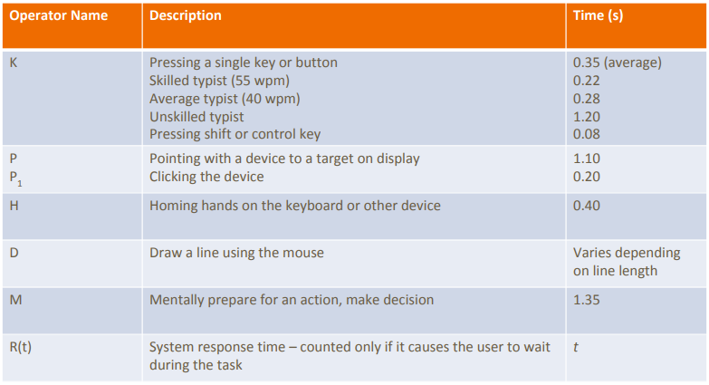

Can be used for comparing alternate ways of executing a task. Does not take time for cognition into account.

## GOMS Model

Stands for Goals, Operators, Methods, and Selection rules. Attempts to model the knowledge and cognitive processes involved when users interact with system*

### Goal

a particular state the user wants to achieve

### Operators

the cognitive processes and physical actions that need to be performed in order to attain goals

### Methods

learned procedures for accomplishing goals. Consist of the exact sequence of steps required

### Selection rules

determine which method to select when there is more than one available for a given stage of a task.

## Seven-Stage Model of interaction

### 7 stages

1. **Forming the goal**: What does the person want to change
2. **Forming the Intention**: What does the person want to do in this step?
3. **Specifying an Action**: What are the exact steps the person decides to take to address the intention?
4. **Executing the Action**: Actually doing the steps that have been chosen, thus acting upon the world
5. 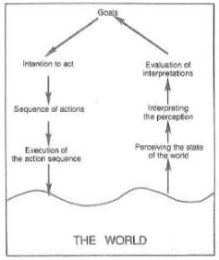**Perceiving the state of the world**: The person must physically perceive the current state of the world, whether changed or unchanged (i.e., see, hear, feel, etc.)
6. **Interpreting the state of the world**: The person must figure out what the perceived changes mean, i.e., what just happened?
7. **Evaluating the outcome**: The person must conclude about whether the original goal has been addressed

### Breakdowns

1. Breakdown in forming the intention
2. Breakdown in specifying the action
3. Breakdown in executing the action
4. Possible breakdown in the interpreting the perception
5. Breakdown in perceiving the state of the world

## Model Human Processor

Three systems: perceptual, cognitive, and motor. Each system has processor and memory. Each system has principles of operation.

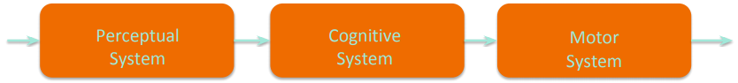

### Cycle time

time between when stimulus is presented and when it is available in buffers. Multiple similar stimuli can combine during one cycle